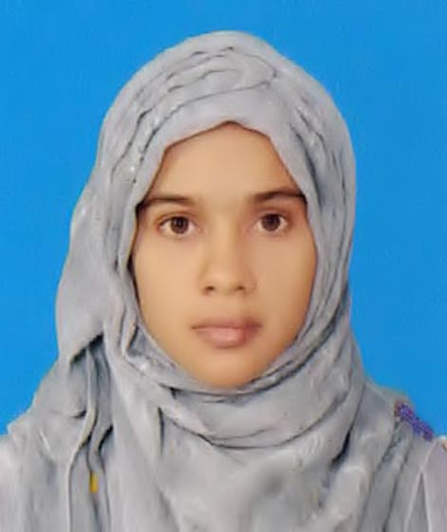
CURRICULUM VITAE

Murshida khatun
মুরশিদা খাতুন
Vill: Shibkuri, P/O: Ambari Daultpur,
P/S: Chirirbandar, Dist: Dinajpur.
Cell: 01768-841260
email: murshidajahan88@gmail.com

Career & Application InformasStion

Career Objective
Because of being young, energetic and active, I want to make myself perfect working hard under supervision of you according to my qualification. Due to build up myself very much strong and for the welfare of human being of our country, I am ready to deliver my knowledge and creativity and so on.

Academic Qualification
Master of Business Administration (M.B.A.)
Institute : Dinajpur Govt. College.
Group : M.B.A. (2 year)
Subject : Accounting
Board : National University.
Year of passing : 2022
Roll : 2295920
Result : 2.75 (out of 4.00).
Bachelor of Business Studies (B.B.S)
Institute : Ambari Degree College.
Group : B.B.S
Board : National University.
Year of passing : 2018
Result : 3.42 (out of 4.00).

Higher School Certificate (H.S.C)
Institute : Ambari Degree College.
Group : Business Group.
Board : Dinajpur
Year of passing : 2015
Roll : 529247
Result : GPA- 4.17 (out of 5.00).
Secondary School Certificate (S.S.C)
Institute : Brohmapur Shahapur Bahumukhi Fadil Madrasah.
Group : Science.
Board : Madrasah.
Year of passing : 2013
Roll : 422105
Result : GPA- 3.88 (out of 5.00)

COMPUTER SKILL

1.Microsoft Office Application MS:(Word, Excess, PowerPoint, publishers,
Outlook), Internet Browsing.

hObbY

- Name Reading, Traveling and Watch Television News.

Personal Information

Name : Murshida Khatun.
Father's Name : Md. Mokbul Hosen.
Mother's Name : Minara Begum.
Spouse Name : MD. AKTARUZZAMAN
Date of Birth : 27/07/1997
Sex : Famale
Religion : Islam
Marital Status : Married
Nationality : Bangladeshi.
Present Address : Vill: Shibkuri, P.O: Ambari Daultpur,
P.S: Chirirbandar, Dist: Dinajpur.
Permanent Address : Care Of :MD. MOKBUL HOSEN Vill: Shibkuri, P.O: AMBARI (DOULOTPUR), Upazila/P.S: Chirirbandar, Dist:Dinajpur.
Present Address (বর্তমান ঠিকানা): Care Of: MD. AKTARUZZAMAN Vill/Road/House/Flat: CHIRIRBANDAR (MAJHAPARA)
District:Dinajpur Upazila/P.S. : Chirirbandar Post Office: CHIRIRBANDAR Post Code: 5240
Blood Group : B (+ve)
Height : 5 Feet 2 inch
Home District : Dinajpur
National ID No : 8701585963.
Contact Number : 01768-841260
lANGUAGE sKILL
Bengali : Native.
English : Reading, Writing Fluently and Speaking Medium

Interests

I am able to work in a team Environment, Reading, Playing, Traveling, and in challenging works.

Declaration

I am undersigned, hereby declare that at the information included here are true to my knowledge. If required and where applicable, this document can be supported by appropriate authentic certificates.

Sincerely yours


-------------------------------
Murshida Khatun

